 | Dr D Y Patil Pratishthan’s  Dr. D.Y. Patil Institute of Engineering, Management and Research, Akurdi, Pune
Academic Year: 2025-26 | BE Project Synopsis | Revision : 00 Dated : 20/11/2019
Term – I | Department: Artificial Intelligence and Data Science | Date of Preparation :

Project Title | AntarAalay.ai: AI-Powered Vastu Interior Design Platform
Domain Name | Artificial Intelligence, Interior Design Automation
Group Leader | Soham Gulhane
Group Member | Sujit Nirmal  Suhani Yadav  Swarup Mandhare
Guide Name | Ms. Surbhi Pagar, Mrs. Reena Sahane

ABSTRACT:

An AI system simplifies interior design with the application of generative models and real-time sensing. Users can upload home pictures or simple room videos and process them to create interactive 3D room models with suggested furniture placement .The system integrates two key modules: an AI-powered Vastu Shastra analyzer that examines layouts based on conventional Indian concepts and a Pandit Chatbot that is pre-trained to respond to popular Vastu queries with expert-suggested answers. The process enables users to design and analyze their space through a combination of contemporary technology and acient vastu concepts helps in home planning and culturally relevant .

Keywords: Interior Design, Generative Models, 3D Layout, Vastu Shastra, Real-Time Sensing, Automation

MOTIVATION:

Less Planning Time: Automates the creation of 3D room models and furniture layouts, dramatically accelerating the design process .Increased Visualization: Enables users to visualize their design concepts in interactive 3D, eliminating guesswork and expensive mistakes

Cultural Relevance: Applies traditional Vastu Shastra principles to ensure designs are stimulating, fostering harmony and balance, and attractive to users seeking culturally appropriate design.

Accessibility: Facilitating non-professionals to be able to access interior design without advanced skill or high-tech software.

Improved Decision Making: Enables users to make smart design decisions with rational, AI-driven recommendations backed by the latest technology and sound architectural practices.

OBJECTIVES:

Create a smart and self-managed software to assist users in interior design

Automatically generate accurate 3D room plans from low-level video feeds.

Offer customized furniture planning guidance through AI that meets functionality and design requirements.

Integrate Vastu Shastra principles to enhance the designed plans to enhance harmony and balance

Develop an easy-to-use application that provides advanced interior design capability, regardless of the user's level of technical skill.

ARCHITECTURE DIAGRAM:

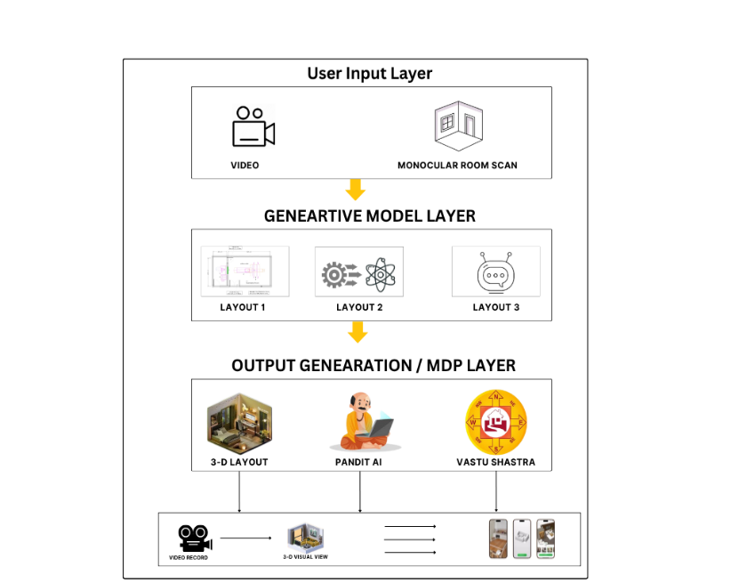

APPLICATION AREAS

:Personal Use : For homeowners and to plan renovations and experiment with furniture layouts virtually.

Real Estate: To virtually equip vacant buildings for more appealing online listings.

Professional Designers: As a tool for rapid prototyping and presentation to clients.

Small Business Owners – To create Vastu-friendly store or office layouts without the professional assistance of a designer.

CONCLUSION:

AntarAalay.ai revolutionizes interior design by merging AI automation with traditional Vastu principles. It reduces costs, saves time, and provides culturally relevant layouts that improve harmony in living spaces. The system’s simplicity ensures that interior design becomes accessible to everyone, bridging the gap between expert-level design and everyday user needs.

.

Name and Sign. of Students - Sign. of Guide

